Name: NGO TUNG CHUONG
ID: s225586848
YouTube: Recorded Video
GitHub: https://github.com/NoXxChapter/SIT221-DataStructure.git

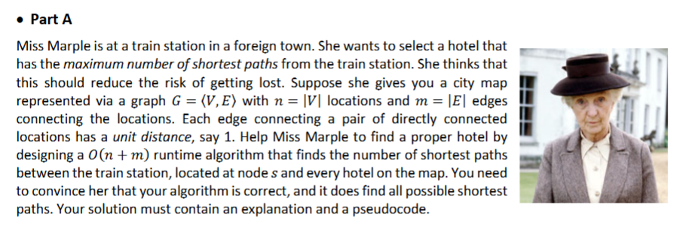
Input: Graph G with s as starting node
Output: count[] array where count[v] is the number of shortest paths to v

Pseudocode of BreadthFirstSearch(G, s):
Initialize dist[n] to infinity, count[n] to 0, visited[n] to false
dist[s] = 0
count[s] = 1
Create an empty queue Q
Q.enqueue(s) // put start node in queue
visited[s] = true // we set start node as visited

// we utilize the First In-First Out rule
while Q is not empty:
currentNode = Q.dequeue()
for each neighbor i of currentNode:
if not visited[i]:
visited[i] = true
dist[i] = dist[currentNode] + 1
count[i] = 1 // we found first shortest path to reach this node
Q.enqueue(i)
else if dist[i] == dist[currentNode] + 1:
count[i] = count[i] + 1 // accumulate the shortest paths that we found
return count
Breadth First Search explores nodes layer by layer. So, when we first encounter a neighbor node i from currentNode, we know right away that is the shortest distance. But if any other node that reaches that neighbor node we already visited with that same distance. We can I accumulate another alternative shortest path, by that we can know all the shortest paths we can travel to reach that desire node.

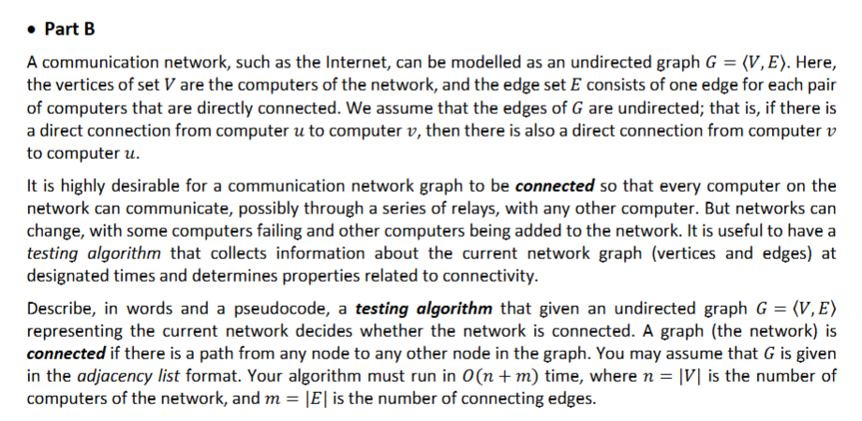
Input: Undirected graph G in adjacency list format
Output: True if connected, False otherwise

Pseudocode of IsConnected(G):
Starting node s
Initialize visited[n] to false
count = 0
Create a queue Q and enqueue s
visited[s] = true

while Q is not empty:
u = Q.dequeue()
count = count + 1
for each neighbor v of u:
if not visited[v]:
visited[v] = true
Q.enqueue(v)

if count == total_number_of_nodes:
return True
else:
return False
Starting from one node, the algorithm visits every node reachable via existing edges. If the total number of visited nodes equals n. Then every node is reachable from the start, which confirming the connectivity. It kind of look like Bellman-Ford but instead of calculating all the shortest path to reach from start node to every other node. This time we only check if start node can reach every node. Because all the edges are undirected, so if it can be reached, then it can reach to others as well.

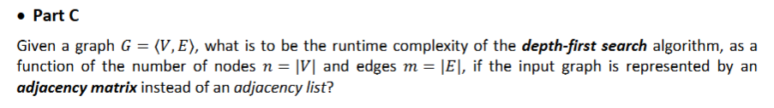
In Depth-First Search (DFS) using an adjacency list, the runtime is O(n+m) because we only look at existing edges. However, if an adjacency matrix is used. Then, to find the neighbours of a single node A for sample, the algorithm must scan the entire row of A which contain n columns. And so, since DFS visits each of the n nodes, it must perform this n-column scan times. With that, the total runtime is $O(n^{2})$.

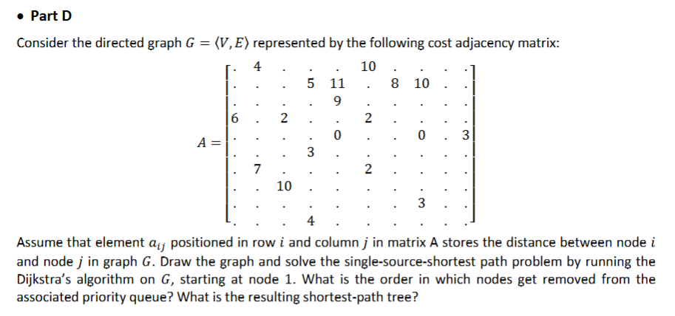
Priority Queue (PQ)
Current Node | Distance | Reached Path from node 1
1 | 0 | 1
2 | 4 | 1 2
3 | 11 | 1 2 4 3
4 | 9 | 1 2 4
5 | 15 | 1 2 5
6 | 10 | 1 6
7 | 12 | 1 2 7
8 | 14 | 1 2 8
9 | $$∞$$ | unreachable
10 | 18 | 1 2 5 10

Remove order: 1 2 4 6 3 7 8 5 10 9

Shortest Paths
$$1→2 \left(weight 4\right)$$
$$1→6(weight 10)$$
$$2→4 (weight 5)$$
$$2→5 \left(weight 11\right)$$
$$2→7 \left(weight 8\right)$$
$$2→8 \left(weight 10\right)$$
$$4→3 \left(weight 2\right)$$
$$5→10 (weight 3)$$
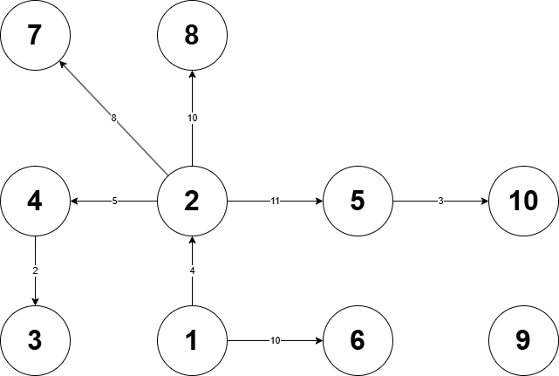

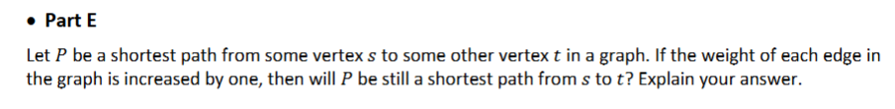
No, not every case though. Because the shortest paths depend on the total sum of weights. If path A has 1 edge with weight 10 and path B has 5 edges with weight 2 each, they both originally total 10. For example, if adding 1 to every edge, then path A total would be 10 + 1 = 11 and path B is now 10 + (5 x 1) = 15. So now, path A is now shorter than Path B. The algorithm now favors paths with fewer edges.

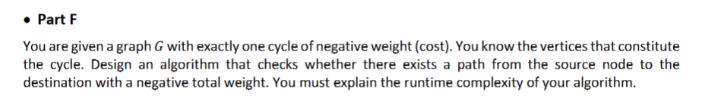
Input: Graph G, source s, destination t, set of vertices in the negative cycle
Output: True if a negative weight path exists, False otherwise

Pseudocode of CheckNegativeCycle(G, s, t, nodeList):
// check if startNode can reach negative node,
// and from negative node it can reach goal
negativeReachable = false
for each v in nodeList:
if DFS_check(G, s, v):
negativeReachable = true
break

goalReachable = false
for each v in nodeList:
if DFS_check(G, s, v):
goalReachable = true
break

if (negativeReachable AND goalReachable):
return true

// ----------------------------------------------------
// if negativeNode is out of reach,
// then we use Bellman-Ford to find the shortest path from start to goal
dist[] = array of size n, initialize to infinity
dist[s] = 0 // set first node path cost to 0

for i from 1 to V - 1:
for each edge (u,v) with weight w in E:
if dist[u] + w < dist[v]:
dist[v] = dist[u] + w

// check if the best path we found has negative total weight or not
if dist[t] < 0:
return true
else
return false
So, the runtime complexity is $O(n∙m)$, where n is the number of vertices and m is the number of edges. Even though, the reachability (DFS, we can also use BFS) take total $O(n+m)$ time. But Bellman-Ford iterates through all m edges n – 1 time, resulting in $0\left(n∙m\right)$. In the end, $0\left(n∙m\right)$grow faster than $O\left(n+m\right)$so $0\left(n∙m\right)$ is the final runtime.

